Data Analysis Project Summary

Project Title: Pizza Sales Performance Analysis
Tools Used: Excel and SQL
Data Source: Excel workbook
Project Goal / Business Question: Analyze key indicators for our pizza data to gain insights into our business performance. Specially want to calculate the following metrics:
KPI’S REQUIREMENT
- Total Revenue: The sum of total price of all pizza orders.
SQL QUERIES: Select SUM(total_price)AS Total_Revenue from pizza_sales$
Total_price -Make sure Total price is written exactly like the column name)
pizza_sales- name of our table
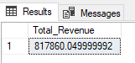
- Average Order Value: The average amount spent per order, calculated by dividing the total revenue by the total number of orders.
SQL QUERIES: SELECT SUM(total_price) / COUNT(DISTINCT order_id)as Avg_Order from pizza_sales$
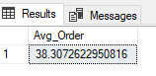
- Total Pizzas Sold: The sum of the quantities of all pizzas sold.
SQL QUERIES: SELECT SUM(quantity) as Total_Pizza_Sold from pizza_sales$
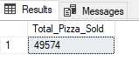
- Total Orders: The total number of orders placed.
SQL QUERIES: SELECT COUNT(DISTINCT order_id) AS Total_orders from pizza_sales$
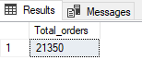
- Avg Pizzas Per Order: The avg no. of pizzas sold per order, calculated by dividing the total no. of pizzas sold by the total no. of orders.
SQL QUERIES: SELECT SUM(quantity) / COUNT (DISTINCT order_id) AS Avg_Pizzas_Per_Order from pizza_sales$
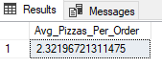
OR if we want to show only 2 decimal
SQL QUERIES: SELECT CAST(CAST(SUM(quantity) AS DECIMAL(10,2)) / CAST(COUNT(DISTINCT order_id) AS DECIMAL (10,2)) AS DECIMAL(10,2)) AS Avg_Pizzas_Per_Order FROM pizza_sales$
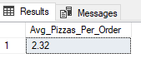
CHARTS REQUIREMENT
- Daily Trend for Total Orders: Create a bar chart that displays trend of total orders over a specific time period. This chart will help us identify any patterns or fluctuations in order volumes on a daily basis.
SQL QUERIES: SELECT DATENAME(DW, order_date) as order_day, COUNT(DISTINCT order_id) AS Total_orders from pizza_sales$
GROUP BY DATENAME(DW, order_date)

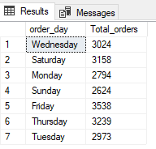
- Hourly Trend for Total Orders: Create a line chart that illustrates the hourly trend of total orders throughout the day. This chart will allow us to identify peak hours or periods of high order activity.

SQL QUERIES: SELECT DATEPART(HOUR, order_time) AS order_hours, COUNT(DISTINCT order_id) AS Total_orders from pizza_sales$
GROUP BY DATEPART(HOUR, order_time)
ORDER BY DATEPART(HOUR, order_time)
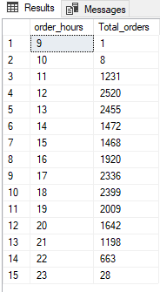

- Percentage of Sales by Pizza Category: Create a pie chart that shows the distribution of sales across different pizza categories. This chart will provide insights into the popularity of various pizza categories and their contribution to overall sales.

SQL QUERIES: SELECT Pizza_category, sum(total_price) * 100 / (SELECT sum(total_price) from pizza_sales$) AS PCT
from pizza_sales$
GROUP BY pizza_category
PCT is percentage of sales which is the same as total price – open pivot table and select pizza category and total_Price
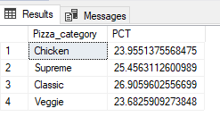
If we want to Add Total Price Column the SQL Queries will be: SELECT Pizza_category, SUM(Total_price) as Total_Sales, sum(total_price) * 100 / (SELECT sum(total_price) from pizza_sales$) AS PCT
from pizza_sales$
GROUP BY pizza_category

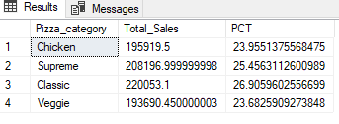
If we want to make the number after point to be only 2 digits the SQL Queries will be: SELECT Pizza_category, CAST(SUM(Total_price) AS DECIMAL (10,2)) as Total_Sales, CAST(sum(total_price) * 100 / (SELECT sum(total_price) from pizza_sales$) AS DECIMAL(10,2)) AS PCT
from pizza_sales$
GROUP BY pizza_category
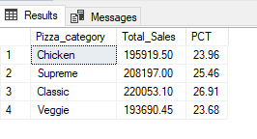
Note: If you want to apply the Month, Quarter, Week filters to the above queries you can use WHERE clause, follow some of bellow examples
SELECT DATENAME(DW, order_date) as order_day, COUNT(DISTINCT order_id) AS Total_orders from pizza_sales$
WHERE MONTH (order_date) = 1
GROUP BY DATENAME(DW, order_date)

Were MONTH (ORDER_DATE) = 1 indicates that the output is for the month of January.

SELECT DATENAME(DW, order_date) as order_day, COUNT(DISTINCT order_id) AS Total_orders from pizza_sales$
WHERE DATEPART(QUARTER,order_date) = 1
GROUP BY DATENAME(DW, order_date)

Were DATEPART(QUARTER,order_date) = 1 indicates that the output is for the Quarter 1.

- Percentage of Sales by Pizza Size: Generate a pie chart that represents the percentage of sales attributed to different pizza. This chart will help us understand customer preferences for pizza sizes and their impact on sales.
SQL QUERIES: SELECT Pizza_size, CAST(SUM(Total_price) AS DECIMAL (10,2)) as Total_Sales, CAST(sum(total_price) * 100 / (SELECT sum(total_price) from pizza_sales$) AS DECIMAL(10,2)) AS PCT
from pizza_sales$
GROUP BY pizza_size

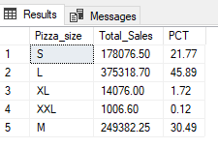
If we want to make in in descending order and want to get the 1st quarter result only we will use the ff queries: SELECT Pizza_size, CAST(SUM(Total_price) AS DECIMAL (10,2)) as Total_Sales, CAST(sum(total_price) * 100 / (SELECT sum(total_price) from pizza_sales$ WHERE DATEPART(quarter, order_date)=1) AS DECIMAL(10,2)) AS PCT
from pizza_sales$
WHERE DATEPART(quarter, order_date)=1
GROUP BY pizza_size
ORDER BY PCT DESC
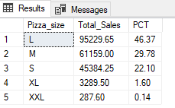
- Total Pizzas sold by pizza category: Create a funnel chart that presents the total number of pizzas sold for each pizza category. This chart will allow us to compare the sales performance of different pizza categories.
SQL QUERIES: SELECT Pizza_category, sum(quantity) as Total_Pizzas_Sold from pizza_sales$
Group by pizza_category
Order by Total_Pizzas_Sold DESC

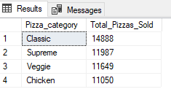
- Top 5 best sellers by Total Pizzas Sold: Create a bar chart highlighting the top 5 best- selling pizzas based on the total number of pizzas sold. This chart will help us identify the most popular pizza options.
SQL QUERIES: SELECT TOP 5 Pizza_name, sum(quantity) as Total_Pizzas_Sold
from pizza_sales$
Group By pizza_name
ORDER BY sum(quantity) DESC
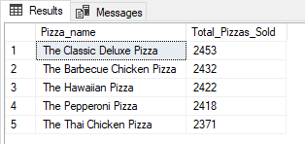

- Bottom 5 Worst Sellers by Total Pizzas Sold: Create a bar chart showcasing the bottom 5 worst-selling pizzas based on the total number of pizzas sold. This chart will enable us to identify underperforming or less popular pizza option.

SQL QUERIES: SELECT TOP 5 Pizza_name, sum(quantity) as Total_Pizzas_Sold
from pizza_sales$
Group By pizza_name
ORDER BY sum(quantity) ASC

